Notice to Applicants

We are pleased that you have chosen to apply for a Native English Teacher position in Gyeonggi Province, Korea.
Here in Gyeonggi Province, the schools hire teachers directly under the guidance of Gyeonggi Provincial Office of Education. This job application package will be used as the standard form within Gyeonggi province so in order to find a position in Gyeonggi Province, please fill this form out and hand it in to your recruiter or school directly.
To be sure that your application receives full consideration, you must fill out the application form completely and accurately. Information from this form will be processed in accordance with the Data Protection Act. The information you provide is an essential component to the hiring and the immigration process.
We wish you good luck and look forward to have you on board.
※ Please visit gepik/wikispaces.com for more information on the GEPIK contract.

GYEONGGI ENGLISH PROGRAM IN KOREA
Job Application Package 2024

Please place this completed checklist on top of your application form along with other documents in order as listed below.

CHECKLIST | TICK
1. Application Form with a glued passport photo | □
2. Resume | □
3. Copy of Passport photo page | □
- Educational Documents:  - Sealed University Transcript  - Apostillized copy of Degree  - TESOL/TEFLE Certificate (min of 100hrs) | □  □  □
- At least two or more References (Personal & Professional Reference)  - Your Professional Reference(s) should describe:  - Work duties and performance  - Duration of FULL-TIME employment  - Full contact information of the referee/employer  - Your Personal Reference(s) should describe:  - Your character and full contact information of the referee | □
- Criminal Record Certificate  - Must be:  - Apostilled or confirmed by the consul at a diplomatic mission abroad  - Issued within 6 months from the application date  - A nationwide criminal background check from your own country’s government which covers the whole country’s information  - Please note that possession of any criminal record will immediately disqualify  you from gaining employment in GEPIK | □
7. Self-Health Assessment * | □
8. Three copies of signed Contract | □
9. Two copies of Security Deposit Agreement | □

Please DO NOT staple your application package

Please note:

- In accordance with the immigration law, only one of the seven designated English Speaking Countries’ citizens are eligible to work as a ‘Foreign Language Instructor’.

- Ensure you have obtained all the documents as specified BEFORE sending them.
- All documents except for original diploma(s) or certificate(s) become property of GPOE and will not be returned. Unless specified to provide the ‘original’, or ‘notarized copy’, you may submit a plain photocopy.

- Any costs involved in obtaining the required documents are borne by the applicant. This includes the mandatory health check upon your arrival in Korea.

- Self Health Assessment Report
Upon successful acceptance into GEPIK, a formal medical examination must be completed in Korea at an approved hospital/public health clinic. The original report must be submitted at the Immigration Office as part of your Alien Registration Card. Please note that a positive result of illegal drug use, alcoholism, or communicable diseases will result in the immediate cancellation of your employment at GEPIK and E2 visa.

Declaration
I certify that all of the above information concerning myself and my background is true to the best of my knowledge. If my documents contain any kind of falsification, I will take any legal responsibility. If I am successful in being selected as a GEPIK teacher, I agree to abide by the regulations and responsibilities outlined in the contract

Signature Date

PLEASE SEND YOUR APPLICATION WITH ALL REQUIRED DOCUMENTS TO YOUR RECRUITER OR SCHOOL

APPLICATION FORM

PERSONAL INFORMATION (PLEASE PRINT)
FIRST NAME (ENTER YOUR LEGAL NAME) |  |  |  |  |  | MIDDLE NAME INITIAL |  | You must attach a passport quality photo of your face and shoulders here
SURNAME
DATE OF BIRTH  YYYY – MM - DD |  |  |  | GENDER  MALE ◻ FEMALE ◻
CURRENT ADDRESS
STREET #
STREET NAME
CITY
STATE/PROVINCE
POSTAL CODE
COUNTRY
MAILING ADDRESS (WHERE YOU WILL RECEIVE YOUR CONTRACT)
STREET #
STREET NAME
CITY
STATE/PROVINCE
POSTAL CODE
COUNTRY
EMAIL ADDRESS |  |  |  |  | TELEPHONE NUMBER  (INCL COUNTRY CODE & AREA CODE)
PRIMARY CITIZENSHIP |  |  | SECONDARY CITIZENSHIP |  |  |  |  | MARITAL STATUS  MARRIED ◻  UNMARRIED ◻
IN ACCORDANCE WITH THE IMMIGRATION LAW, ONLY ONE OF THE SEVEN DESIGNATED ENGLISH SPEAKING COUNTRIES’ CITIZENS ARE ELIGIBLE.
TWO EMERGENCY CONTACTS
NAME |  |  |  |  | NAME
RELATION |  |  |  |  | RELATION
PHONE |  |  |  |  | PHONE
MAIL |  |  |  |  | EMAIL

EDUCATIONAL BACKGROUND (PLEASE PRINT)
LEVEL | NAME OF INSTITUTION | STATE/PROVINCE  /COUNTRY | ENROLLMENT |  | GRADUATION DATE | #  YEARS
 |  |  | FROM | TO
ELEMENTARY |  |  | MM/YY | MM/YY | MM/YY
MIDDLE |  |  | MM/YY | MM/YY | MM/YY
HIGH |  |  | MM/YY | MM/YY | MM/YY
POST SECONDARY (1) |  |  | MM/YY | MM/YY | MM/YY
 | DEGREE: | MAJOR:  MINOR: |  |  | GPA OR %: /  GPA OR %: /
POST SECONDARY (2) |  |  | MM/YY | MM/YY | MM/YY
 | DEGREE: | MAJOR:  MINOR: |  |  | GPA OR %: /  GPA OR %: /
Please note, GEPIK does not recognize degrees obtained from other than one of the seven designated English-speaking countries*. (See note on the 2nd page). For F4 visa holders, you will be asked to provide an official document as proof for a minimum of 10 years of secondary and higher educational background in one of the seven designated English-speaking countries.

ENGLISH TEACHING CERTIFICATION/TEACHING CERTIFICATION
TICK | TITLE OF CERT. | ACCREDITING INSTITUTION | ISSUE  DATE | HOURS  COMPLETED
◻ | TEFL/TESOL/CELT/CELTA |  | MM/YY
◻ | TEACHING CERTIFICATION /LICENSE  /CREDENTIALS |  | MM/YY | N/A
SUCCESSFUL APPLICANTS MUST PROVIDE DOCUMENTED PROOF FOR HOLDING CERTIFICATES.

TEACHING EXPERIENCE (IN CHRONOLOGICAL ORDER)
NAME AND LOCATION OF INSTITUTION | POSITION | SUBJECT(s) TAUGHT | AGES TAUGHT | DATE FROM | DATE TO
INSTITUTION |  |  |  | MM/YY | MM/YY
STATE PROVINCE
COUNTRY
FULL TIME ◻ PART TIME ◻
REASON FOR LEAVING:
INSTITUTION |  |  |  | MM/YY | MM/YY
STATE PROVINCE
COUNTRY
FULL TIME ◻ PART TIME ◻
REASON FOR LEAVING:
INSTITUTION |  |  |  | MM/YY | MM/YY
STATE
PROVINCE COUNTRY
FULL TIME ◻ PART TIME ◻
REASON FOR LEAVING:
INSTITUTION |  |  |  | MM/YY | MM/YY
STATE
PROVINCE COUNTRY
FULL TIME ◻ PART TIME ◻
REASON FOR LEAVING:

NON-TEACHING WORK EXPERIENCE (IN CHRONOLOGICAL ORDER)
NAME AND TYPE  OF BUSINESS | POSITION | JOB DETAILS | DATE  FROM | DATE  TO
EMPLOYER |  |  | MM/YY | MM/YY
STATE
PROVINCE | FULL TIME ◻ PART TIME ◻
COUNTRY | REASON FOR LEAVING:
EMPLOYER |  |  | MM/YY | MM/YY
STATE
PROVINCE | FULL TIME ◻ PART TIME ◻
COUNTRY | REASON FOR LEAVING:
EMPLOYER |  |  | MM/YY | MM/YY
STATE
PROVINCE | FULL TIME ◻ PART TIME ◻
COUNTRY | REASON FOR LEAVING:
EMPLOYER |  |  | MM/YY | MM/YY
STATE
PROVINCE | FULL TIME ◻ PART TIME ◻
COUNTRY | REASON FOR LEAVING:

GENERAL QUESTIONS
1. Have you ever been in Korea before? | YES ◻ NO ◻
If yes, please describe the duration, purpose of stay and your experiences briefly.
2. Have you ever broken any teaching contract? | YES ◻ NO ◻
If yes, please explain why.
3. Do you have any Korean language skills? | YES ◻ NO ◻
If yes, please choose your level below.
Beginner ◻ Intermediate ◻ Advanced ◻
4. If accepted, what is the earliest start date you can work in Korea?

YYYY – MM – DD
5. Which grade level(s) do you prefer to teach?

Elementary (Grade 1~6) ◻, Middle (Grades 7~9) ◻, High (Grades 10~12) ◻, Any Grades ◻
- Please choose your preferred location of the school area

  - City area ◻ (name of the city if applicable: )
  - Designated Rural Area □ (name of the place if applicable: )
* Designated Rural monthly allowance of 100,000 KRW
  - Either ◻
7. Please choose your preferred accommodation location

- Near school ◻ - Near subway station ◻ - Near downtown (if rural location) ◻

-I have my own ◻ (400,000 KRW Monthly allowance applies)
8. What are your personal/professional strengths?
9. What are your personal/professional weaknesses?
Your preferences will be considered,
but cannot guarantee that all preferences will be fulfilled.

Personal Essay (300~500 words, size 11 font, single spaced)
Your personal essay is the most important part of the application process. In the space below, please write a personal essay describing:
- Brief introduction of yourself.
- Experiences that you feel would be helpful to your teaching in Korea.
- Why you want to (continue) teach and live in Korea.
- Your philosophy of teaching/education.

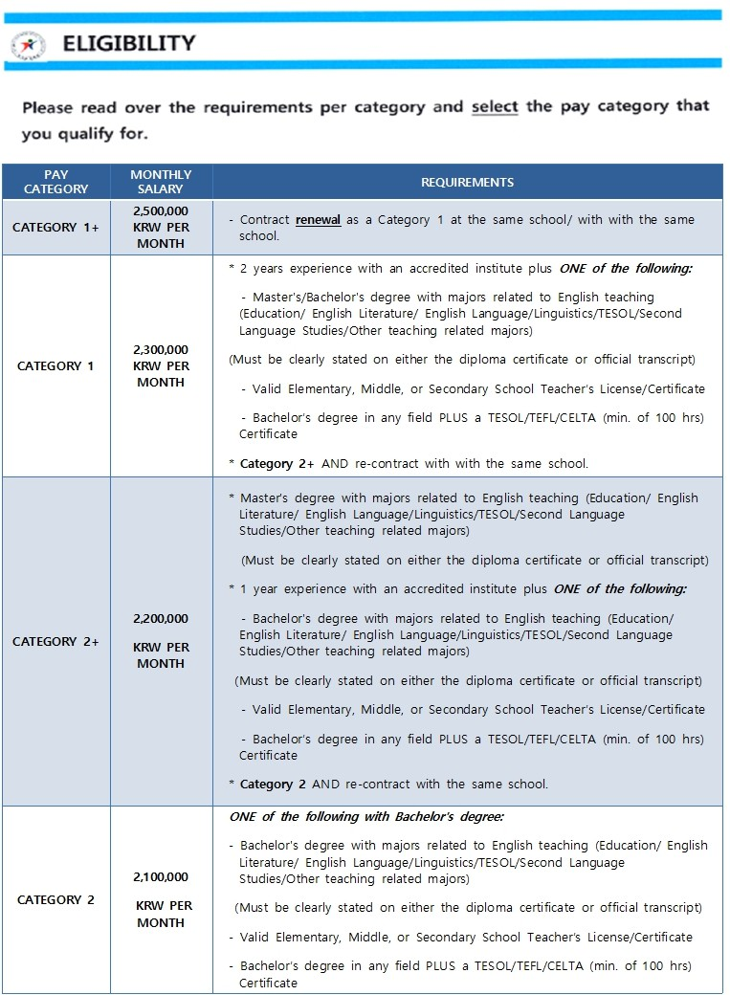
‘학생중심, 현장중심교육’

- 77 -

ATTACHMENT 1. Application agreements

SALARY LEVEL
Salary is standardized according to qualifications and/or teaching experience. Please note that only full-
time teaching experience of a minimum of “one full academic year” makes an applicant eligible for a higher salary and only an employment verification letter issued by district or provincial education board will be acceptable. Also, TEFL and TESOL training must consist of a minimum of 100 hours and be proved with documentation.
Please list the pay level that you CURRENTLY qualify for and the level you expect to qualify for when you begin the GEPIK
contract (based on expected completion of TEFL/TESL certification and/or teaching experience).

 | LEVEL 2 | LEVEL 2+ | Level 1 | Level 1+
CURRENT QUALIFICATION
EXPECTED QUALIFICATION

- CRIMINAL RECORD
Have you ever been charged (whether convicted or dismissed) with anything more serious than a minor traffic offense?**

YES NO

**NOTE: ALCOHOL- OR SUBSTANCE-RELATED TRAFFIC OFFENCES ARE NOT CONSIDERED MINOR
- MINIMUM EDUCATIONAL REQUIREMENTS
Have you studied in one of the seven (7) designated English-speaking countries beginning from the first year of middle school through high school and university for a minimum total of 10 years AND do you now or will you soon hold a Bachelors degree or its equivalent?
Are you aware GEPIK requires minimum 100hours teaching certificates such as TEFL/TESOL or valid teaching license unless you are Bachelor’s degree with a major in English or education?
- MINIMUM TEACHING CERTIFICATE REQUIREMENTS

4. REQUEST OF DRUG AND HIV TEST
Are you aware cannabinoid, drug and HIV test will be requested upon your arrival according to Korean immigration regulations? Also any possession, merchandise, and consumption of cannabis (marihuana) are illegal in South Korea?
5. JOB DESCRIPTION AND WORKING ENVIRONMENT
Are you familiar with the job description and working environment for NET(Native English Teacher)’s descripted on the Korvia website?
6. SUPERVISION AND CO-TEACHER
Are you aware that you will be under the direct supervision by your co-teacher and he/she may request that you fulfill certain tasks on behalf of your employer?
7. Are you aware that your employer may add or remove certain lists of duties and responsibilities from the standard GEPIK contract according to his/her disrection?
8. CURRENT CONTRACT STATUS
Do you currently hold a contract position in Korea? If yes, please give the exact finish date below (you will be able to find your expired date on your ARC card.)

** STARTING DATE OF MARCH 2015 SEMESTER IS ON 1ST MARCH | M | M | D | D | Y | Y | Y | Y

9. Are you aware that your provided housing or housing allowance cannot be changed after the first day of employement?
10. Are you aware that your contract may become invalid due to failure of submitting the required documents according to GEPIK regulations?
11. Are you aware that your expected qualification (salary level) only will be vaild when
12. Are you aware that you need to be prepared to bring the equivalent of 1,000USD to support your stay during the first month of your contract?
13. Are you aware of the potential that you might work at more than one school and/or that that school(s) may be located in a rural area?
14. Are you aware that, although GEPIK tries intentionally to place you as close to your school(s) as possible, you may be required to commute up to appr. 60 min.?

The answers I have provided throughout this application are true and correct to the best of my knowledge and I will bear full legal and financial responsibility for any errors or falsehoods contained herein.

FIRST NAME MIDDLE INITIAL LAST NAME

SIGNATURE (DIGITAL APPLICANTS MUST TYPE HERE AND SUBMIT INK SIGNATURES LATER)
MM / DD / YYYY

ATTACHMENT 2. Consent For Verification
DATE

you submit the complete set of required documents according to the GEPIK salary criteria before the first day of your employment?
CONSENT FOR VERIFICATION
AND COLLECTION OF PERSONAL INFORMATION

FIRST NAME |  | MIDDLE NAME |  |  |  | LAST NAME | GENDER
 |  |  |  |  |  |  | M |  | F
ADDRESS (NO., ST., APT.) |  |  | CITY |  | STATE/PROVINCE |  | ZIP CODE |  | COUNTRY
BIRTH DATE (MM-DD-YY) | PLACE OF BIRTH |  |  | TELEPHONE NUMBER (COUNTRY & AREA CODE) |  |  | E-MAIL
I hereby authorize the Gyeonggi English Program in Korea (GEPIK) or school under the Gyeonggi Provincial Office of Education to verify on my behalf the information disclosed in this application form and the documents required by GEPIK as well as collect other information deemed necessary by GEPIK to determine the applicant’s suitability from any institution, organization or individual issuing said information and/or documentation.

FIRST NAME MIDDLE INITIAL LAST NAME
MM / DD / YYYY

SIGNATURE (DIGITAL APPLICANTS MUST TYPE HERE AND SUBMIT INK SIGNATURES LATER)
DATE

※INFORMATION OF AUTHORIZED ORGANIZATION

Gyeonggi English Program in Korea (GEPIK)
Gyeonggi Provincial Office of Education (GPOE)

Phone +81-31-249-0114 Website www.goe.go.kr
Address 495 Jowondong (15 worldcup street) Jangan-gu, Suwon City, Gyeonggi Province, South Korea 440-702

